**Chapter 4:**

**Introduction to Differential Equations**

**4.5 First-order Linear Equations**

**Section Exercises**

**Are the following differential equations linear? Explain your reasoning.**

209. 

Answer: Yes

211. 

Answer: Yes

**Write the following first-order differential equations in standard form.**

213. 

Answer: 

215. 

Answer: 

217. 

Answer: 

**What are the integrating factors for the following differential equations?**

219. 

Answer:

221. 

Answer: 

**Solve the following differential equations by using integrating factors.**

223. 

Answer:

225. 

Answer:

227. 

Answer: 

229. 

Answer: 

231. 

Answer: 

**Solve the following differential equations. Use your calculator to draw a family of solutions. Are there certain initial conditions that change the behavior of the solution?**

233. **[T]**

Answer: 

235. **[T]** 

Answer: 

237. **[T]**

Answer: 

239. **[T]**

Answer: 

**Solve the following initial-value problems by using integrating factors.**

241. , 

Answer: 

243. , 

Answer: 

245. , 

Answer: 

247. , 

Answer: 

249. , 

Answer: 

251. A falling object of masscan reach terminal velocity when the drag force is proportional to its velocity, with proportionality constant  Set up the differential equation and solve for the velocity given an initial velocity of 

Answer:

253. **[T]** Using your equation for terminal velocity, solve for the distance fallen. How long does it take to fall  meters if the mass is kilograms, the acceleration due to gravity is m/s2 and the proportionality constant is

Answer: seconds

255. Using your expression from the preceding problem, what is the terminal velocity? (*Hint:* Examine the limiting behavior: Does the velocity approach a value?)

Answer:

**For the following problems, determine how parameteraffects the solution.**

257. Solve the generic equation  How does varying change the behavior?

Answer: 

259. Solve the generic equation  How does varying change the behavior?

Answer: 

261. Solve with the initial condition Asapproaches what happens to your formula?

Answer: 

**Chapter Review Exercises**

***True or False.* Justify your answer with a proof or a counterexample.**

263. The differential equation is separable.

Answer: F

265. You can determine the behavior of all first-order differential equations using directional fields or Euler’s method.

Answer: T

**For the following problems, find the general solution to the differential equations.**

267. 

Answer:

269. 

Answer:

271. 

Answer: 

**For the following problems, find the solution to the initial value problem.**

273. 

Answer:

275. 

Answer:

277. 

Answer: 

**For the following problems, draw the directional field associated with the differential equation, then solve the differential equation. Draw a sample solution on the directional field.**

279.  for 

Answer:

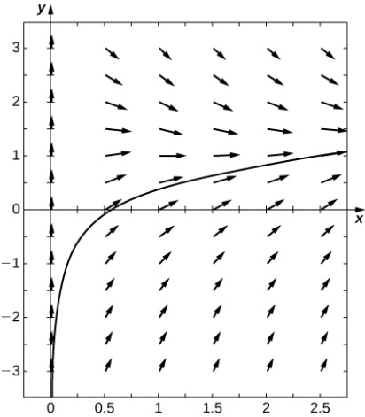



**For the following problems, use Euler’s Method withsteps over the interval. Then solve the initial-value problem exactly. How close is your Euler’s Method estimate?**

281. 

Answer: Euler: exact solution: 

**For the following problems, set up and solve the differential equations.**

283. You throw a ball of mass  kilograms into the air with an upward velocity of  m/s. Find exactly the time the ball will remain in the air, assuming that gravity is given by

Answer:second

285. You drop the same ball of mass  kilograms out of the same airplane window at the same height, except this time you assume a drag force proportional to the ball’s velocity, using a proportionality constant of and the ball reaches terminal velocity. Solve for the distance fallen as a function of time. How long does it take the ball to reach the ground?

Answer:seconds

287. A -liter tank contains pure water and a solution of kg salt/L is pumped into the tank at a rate of  L/min and is drained at the same rate. Solve for total amount of salt in the tank at time 

Answer: 

289. The human population (in thousands) of Nevada in  was roughly If the carrying capacity is estimated at  million individuals, and assuming a growth rate of  per year, develop a logistic growth model and solve for the population in Nevada at any time (use  as time = 0). What population does your model predict for How close is your prediction to the true value of?

Answer:

This file is copyright 2016, Rice University. All Rights Reserved.